Guidelines For Dataset

Process of uploading data

Part I: Downloading a score

1. Log into <https://www.poppiano.org/en/>

(Username and password in Whatsapp group description)

2. Click into *Hong Kong Scores*



3. Click a singer assigned (Please refer to [Job Distribution](https://docs.google.com/spreadsheets/d/1sJ-2V2EDZfF-AETztJs4eyqdWNB-MzeP_SJhfk3poYU/edit#gid=0))

and click the song you want to scrape

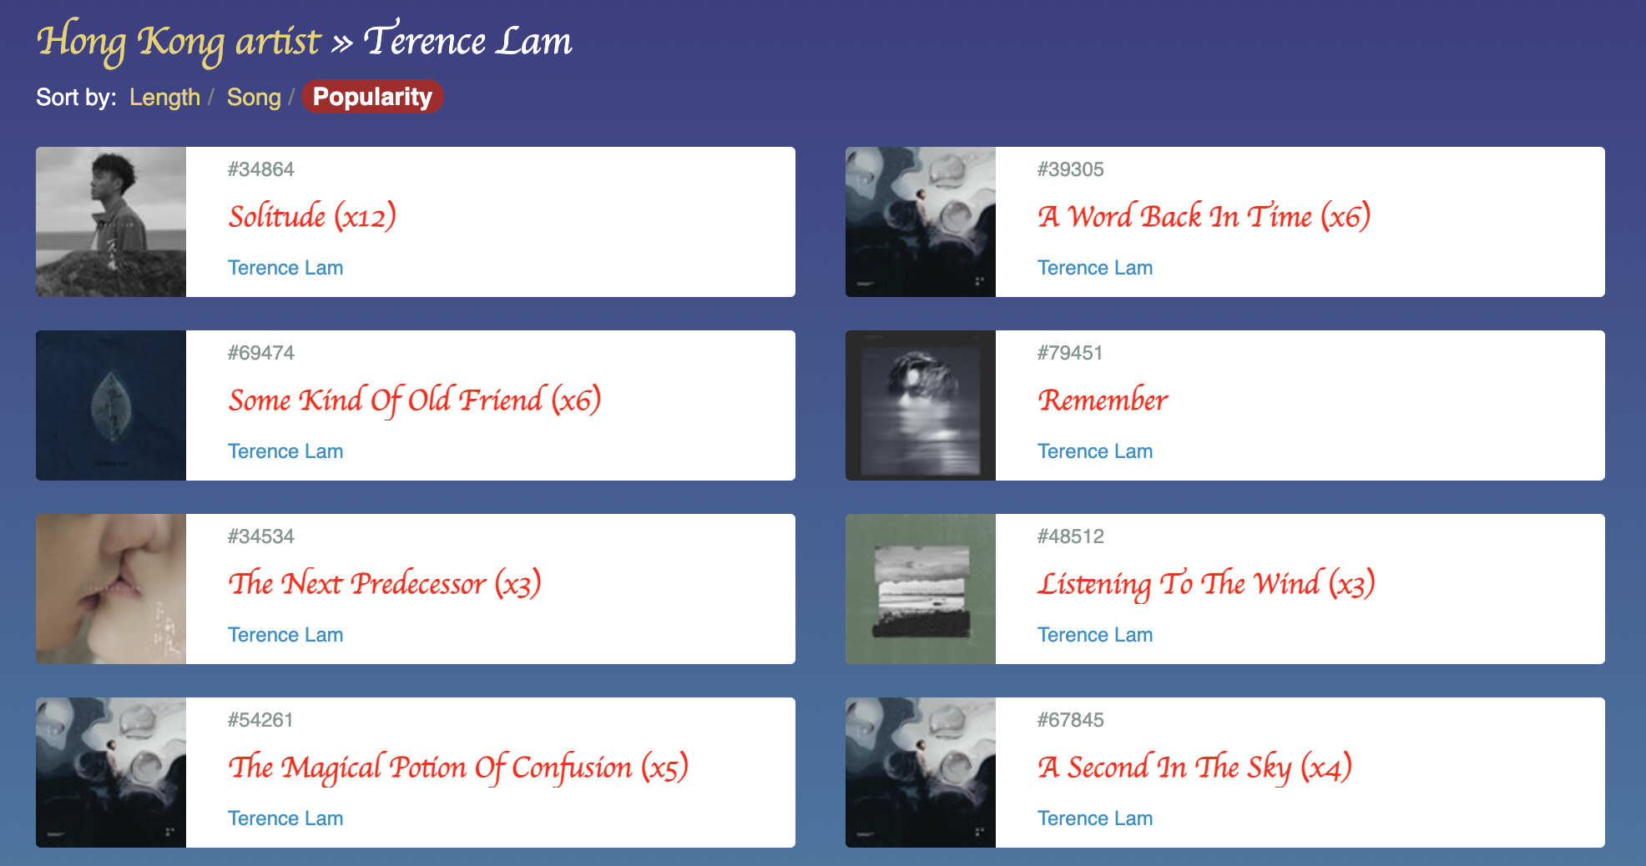

4. Find a piece of score where it has a clear vocal line

**IMPORTANT:** **No time signatures are allowed other than 4/4, 2/4 and 2/2.**

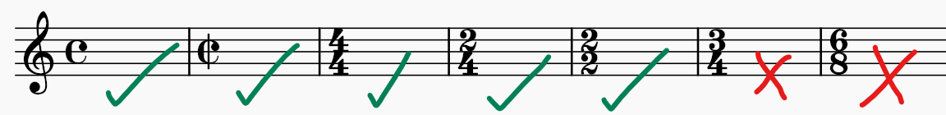

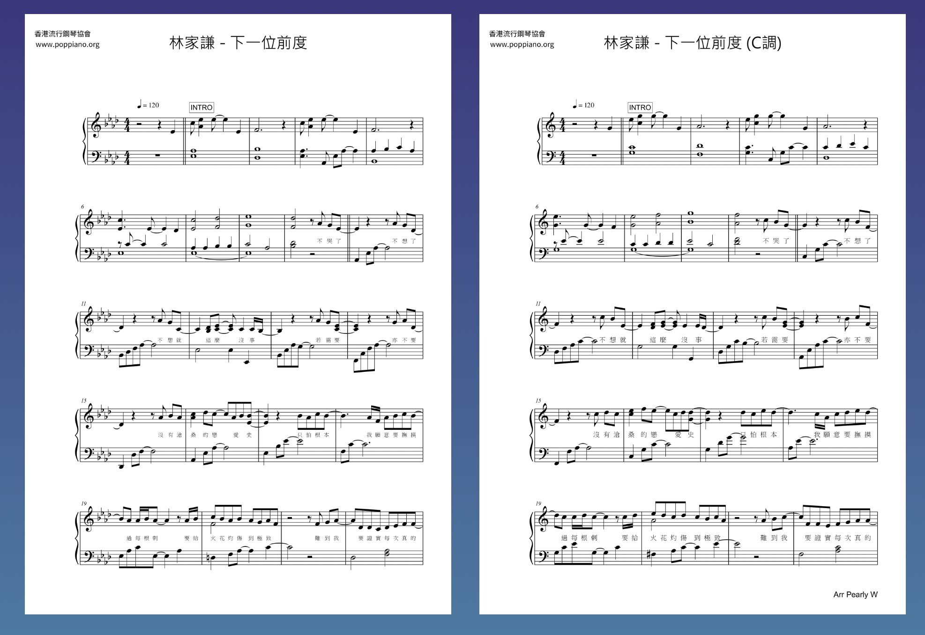

5. Click the score and click “*download as pdf”*

The downloaded score would appear as a .pdf file, in the “*downloads”* folder of your computer

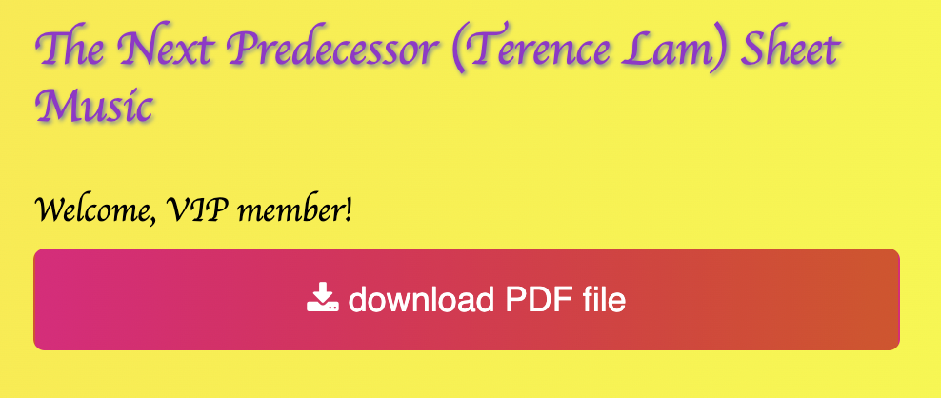

Part II: Converting the .pdf file to .mscz

1. Go to <https://musescore.com/import>

2. Click “Select pdf” and upload the .pdf score you have just downloaded

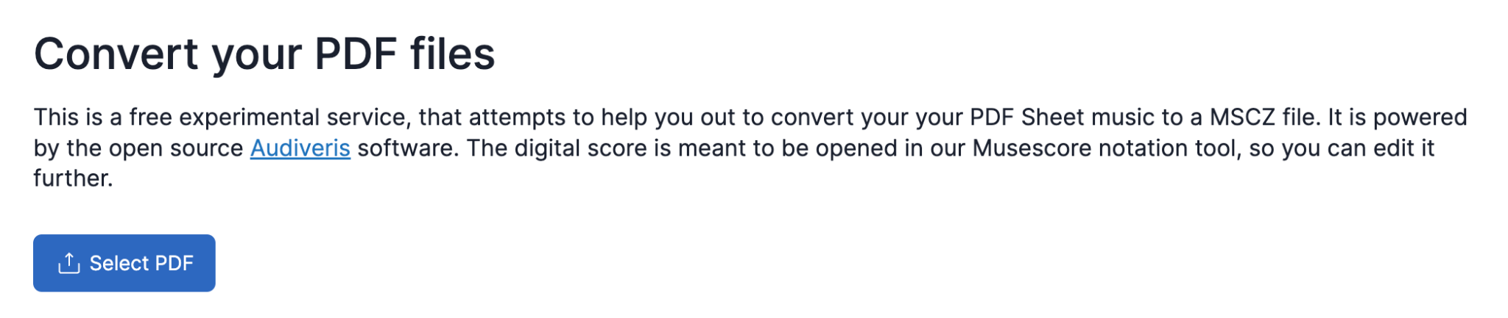

3. Wait around a minute. Download the converted file

If the conversion has failed, you should try using another score   
(If there is no scores left, just give up that song)

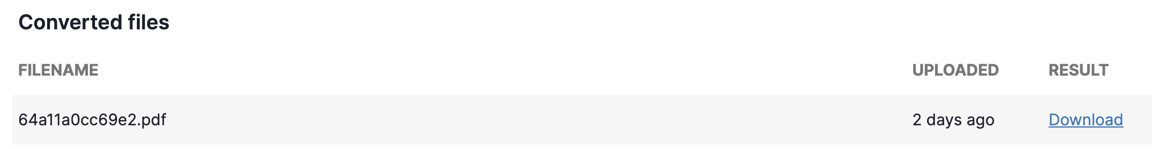

Part III: Editing the .mscz file

Open the file you have just downloaded in *Musescore 3* or *Musescore 4*

1. Delete all other instrument parts other than *Voice* 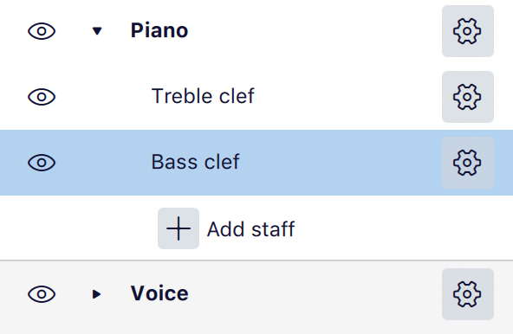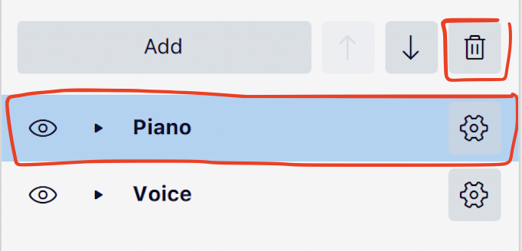

(except if the melody is in *Piano*, then you should delete the *Bass Clef*)

2. Delete unnecessary passages

You should delete the intro, outro and music break of the song, where there are only instruments and no vocal line

3. Amend the following errors during parsing using the following checklist

1. Key signatures

Make sure the key signatures (sharp or flat) are parsed correctly

(Note: If a piece has change of key signatures, please leave it for us to process)

1. Notes

Check the pitch of the notes in the .pdf and the .mscz and make sure all notes are parsed correctly

1. Rhythm

Sometimes musescore may randomly decide to change the time signature of measures. You will see a “-” or “+” sign in the corner.

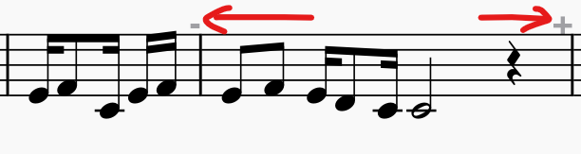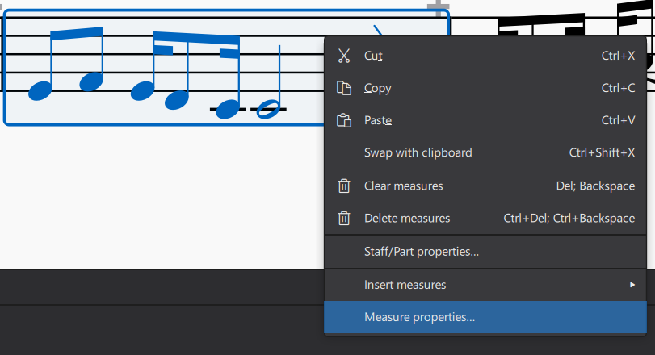

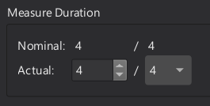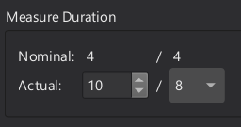

1. Ties

(i) They look identical to slurs so play back once to correct any mistakes

Slurs are two separate notes, while ties are prolongation of one single note

(ii) No tying more than 2 notes

(You may ignore tempo and articulation, e.g. staccato, accent)

4. Add lyrics

Use *LyricsHotKey* to input lyrics

[Instructions on how to use LyricsHotKey](https://docs.google.com/document/d/1BqUUQp-gHDRYsAV_JdXP7LlvVen-lPKziYBTx9nNDTs/edit)

Note: For tied notes, please **only input the lyrics in the first note**

Part IV: Upload the musescore

Upload specifications

1. Upload **at least** the **.mscz** file to the google drive. This file will be used for cross checking.

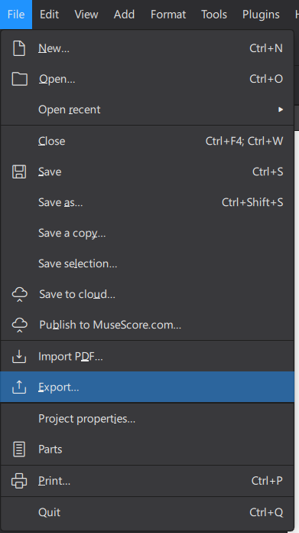

Optional: Export the .mxl file and upload it in conjunction with the .mscz file if you have time.

